



**37_Triangle Judgement Problem**

A pupil Tim gets homework to identify whether three line segments could possibly form a triangle.

However, this assignment is very heavy because there are hundreds of records to calculate.

Could you help Tim by writing a pyspark code to judge whether these three sides can form a triangle,

assuming df triangle holds the length of the three sides x, y and z.

**Difficult Level :** EASY

**DataFrame:**

**# Define the schema for the DataFrame**

**schema = StructType([**

**StructField("x", IntegerType(), True),**

**StructField("y", IntegerType(), True),**

**StructField("z", IntegerType(), True)**

**])**

**# Data to be inserted into the DataFrame**

**data = [**

**(13, 15, 30),**

**(10, 20, 15)**

**]**

|  |
| --- |



**INPUT**

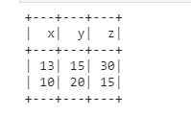

**OUTPUT**





